EventPlan Table (I m using Oracle and Sql Developer Client)
- CREATE TABLE Statement

CREATE TABLE Eventplan
(
Planno varchar2(8) CONSTRAINT Plannoabsent not null,
EventNo varchar2(8) CONSTRAINT Eventnumberabsent not null,
Workdate date CONSTRAINT Workdateabsent not null,
Notes varchar2(50),
Activity varchar2(30) CONSTRAINT Activityabsent not null,
EmpNo varchar2(8),
CONSTRAINT plannoPK PRIMARY KEY(PlanNo),
CONSTRAINT eventnoFK FOREIGN KEY(EventNo) REFERENCES Eventrequest,
CONSTRAINT empnoFK FOREIGN KEY(EmpNo) REFERENCES Employee
);
- Run the above command
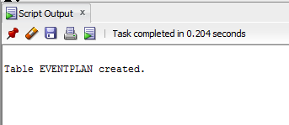
- Insert rows into it

Using Sample insert statements given in the assignment

- Table data
